

Investment Report: Big Yellow Group (BYG LN)

Notes:

* General info (2):
  + UK brand leader in self-storage
  + 99 stores, including 24 stores under the name of Armadillo Self Storage, in which it holds a 20% interest
  + 75 Big Yellow stores (40 in London), 24 Armadillo stores (1 in London), 12 New BY ones under development (1 in London)
  + More than 40 sites within the M25
  + They own a further 12 Big Yellow self-storage development sites, of which 3 have planning consent
  + Of all their stores and sites, 97% held freehold and long leasehold (find out how this affects asset values), along with 3% short leasehold
  + Main clientele: students (very stable, due to the popularity of UK universities around the world), business customers.
  + Demand components: student life, marriage, starting a family, divorce, dealing with death and inheritance. All solid sources of demand that will never go away. Businesses also use them as storage of stock and distribution.
  + 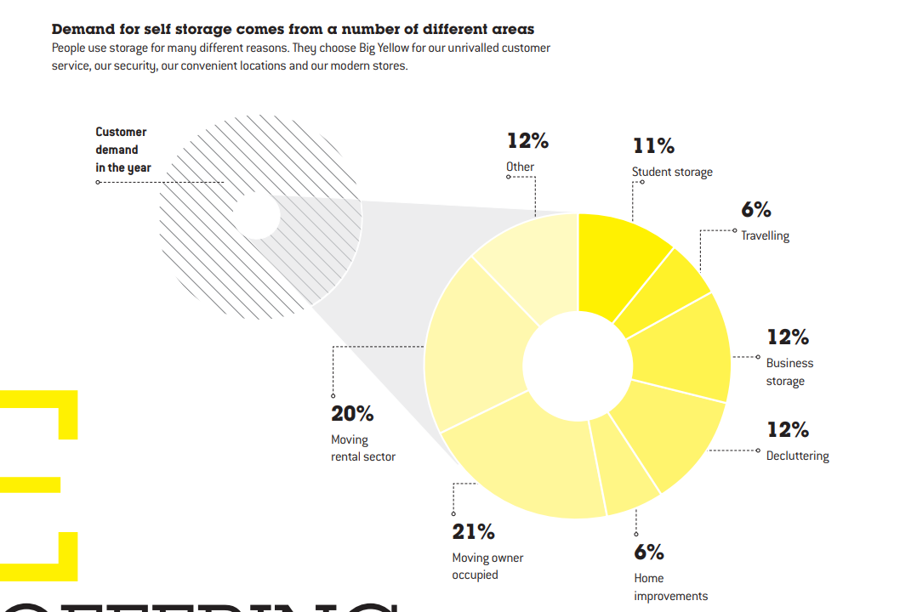
  + How many of their sites are freehold?
  + Mainly concentrated in cities
  + Floated in May 2000
  + Solid business through the downturn
  + 5.7 million sq ft UK footprint (Big Yellow and Armadillo combined)
* Competitors/sector peers:
  + Smaller local storage providers
* Do they sell *good* products?
  + Have a look at repeat purchases, and commonality between bad customer reviews (exit experiences, hidden charges, expensive to start with) (3)
  + All good reviews seem to emphasise friendly and fast service. This is consistent with their annual report
  + All bad reviews are post-service, all good reviews seem to be first-time, pre service (3)
* Look at Safestore, and other storage companies (4)
* Dividend yield of 3.2%
* Dividend growth rate (10Y) of…
* P/E ratio (diluted EPS before extra items)

Halting on this – no point wasting time on one company when the quants could be better for another

Sources

<https://www.standard.co.uk/business/big-yellow-reports-high-demand-for-selfstorage-space-a4398676.html> (1)

<https://corporate.bigyellow.co.uk/application/files/7215/6085/0959/BY_AR2019.pdf> (2)

<https://uk.trustpilot.com/review/www.bigyellow.co.uk?page=11> (3)

<http://www.storage.co.uk/about-self-storage/the-big-operators> (4)